Module 4 – Introduction to DBMS Introduction to SQL
Theory Questions:
1. What is SQL, and why is it essential in database management?
ANS:- SQL (Structured Query Language) is a standard programming language used to store, manage, and retrieve data from a database.
It is mainly used with Relational Database Management Systems (RDBMS) like MySQL, Oracle Database, Microsoft SQL Server, and PostgreSQL.

2. Explain the difference between DBMS and RDBMS.
ANS:-

Difference Between DBMS and RDBMS
Feature | DBMS (Database Management System) | RDBMS (Relational Database Management System)
Definition | Software to manage databases | Advanced DBMS that stores data in tables (relations)
Data Structure | Data stored in files or hierarchical form | Data stored in rows and columns (tables)
Relationships | Does not support relationships properly | Supports relationships using keys (Primary & Foreign)
Normalization | Not available | Available (reduces redundancy)
Data Redundancy | High | Low
Security | Less secure | More secure with user roles & permissions
Users | Single user (mostly) | Multi-user environment
Examples | File System, FoxPro | MySQL, Oracle Database, Microsoft SQL Server

3. Describe the role of SQL in managing relational databases.
ANS:-
Role of SQL in Relational Databases (Short Answer):
SQL is used to create, manage, and manipulate data in relational databases. It helps in:
- Defining database structure (CREATE, ALTER)
- Inserting, updating, and deleting data
- Retrieving data using queries (SELECT)
- Maintaining relationships between tables
- Ensuring data security and integrity

4. What are the key features of SQL?
ANS:-
Key Features of SQL (Short Answer):
- Easy to Learn & Use – Simple English-like syntax
- Data Definition – Create and modify database structure (DDL)
- Data Manipulation – Insert, update, delete data (DML)
- Data Retrieval – Fetch data using queries (SELECT)
- Data Security – Control access using GRANT and REVOKE
- Data Integrity – Ensures accuracy using constraints
- Transaction Control – COMMIT and ROLLBACK for safe operations
- Supports Relationships – Works with multiple related tables

LAB EXERCISES:
• Lab 1: Create a new database named school_db and a table called students with the following columns: student_id, student_name, age, class, and address.

CREATE DATABASE school_db;
USE school_db;

-- Create Database
CREATE DATABASE school_db;

-- Use the database
USE school_db;

-- Create Table
CREATE TABLE students (
student_id INT PRIMARY KEY,
student_name VARCHAR(100),
age INT,
class VARCHAR(50),
address VARCHAR(255)
);
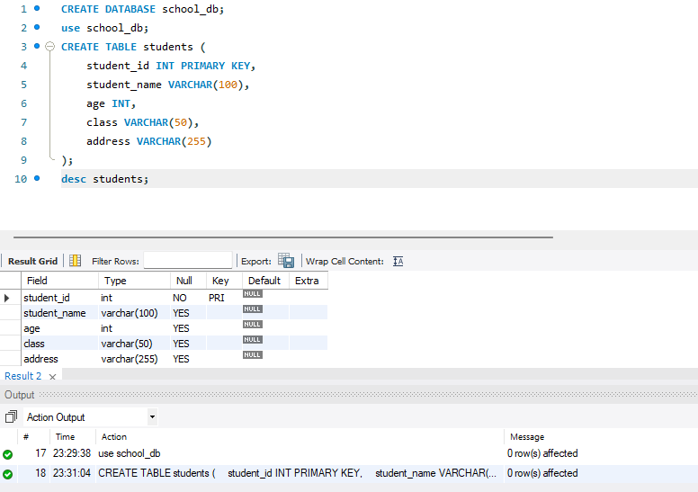

• Lab 2: Insert five records into the students table and retrieve all records using the SELECT statement.
INSERT INTO students (student_id, student_name, age, class, address) VALUES
(1, 'Aarav Patel', 15, '10A', 'Ahmedabad'),
(2, 'Riya Shah', 14, '9B', 'Surat'),
(3, 'Vivaan Mehta', 16, '11A', 'Vadodara'),
(4, 'Ananya Desai', 15, '10B', 'Rajkot'),
(5, 'Krish Gupta', 14, '9A', 'Mumbai');
Select * from students;
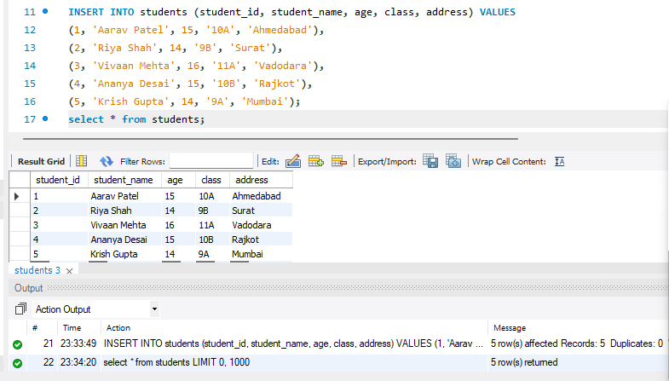

2. SQL Syntax Theory Questions:
1. What are the basic components of SQL syntax?
The basic components of SQL syntax are the building blocks used to write SQL queries. Here are the key components explained simply:

1. Keywords
- Reserved words with special meaning in SQL
- Examples: SELECT, INSERT, UPDATE, DELETE, CREATE, WHERE

2. Identifiers
- Names given to database objects
- Examples: table names, column names, database names
- Example: students, student_name

3. Clauses
- Conditions or parts of a query that define how data is selected or manipulated
- Examples:
  - WHERE → filters data
  - ORDER BY → sorts data
  - GROUP BY → groups data

4. Expressions
- Combination of values, columns, and operators that produce a result
- Example:
age + 5, salary * 2

5. Operators
- Used to perform operations on data
- Types:
  - Arithmetic: +, -, *, /
  - Comparison: =, >, <
  - Logical: AND, OR, NOT

6. Commands / Statements
- Complete instructions given to the database
- Types:
  - DDL (Data Definition Language) → CREATE, ALTER, DROP
  - DML (Data Manipulation Language) → INSERT, UPDATE, DELETE
  - DQL (Data Query Language) → SELECT
  - DCL (Data Control Language) → GRANT, REVOKE

7. Values
- Actual data used in queries
- Example: 'Hetal', 20, 'Surat'

2. Write the general structure of an SQL SELECT statement.

SELECT column1, column2, ...
FROM table_name
WHERE condition
GROUP BY column_name
HAVING condition
ORDER BY column_name ASC/DESC;

• SELECT → Specifies the columns you want to retrieve
• FROM → Specifies the table name
• WHERE → Filters rows based on a condition
• GROUP BY → Groups rows with similar values
• HAVING → Filters grouped data
• ORDER BY → Sorts the result (ascending or descending)

3. Explain the role of clauses in SQL statements.
Role of Clauses in SQL Statements (Short Answer):
Clauses in SQL define how data is selected and processed in a query. They help in filtering, grouping, and sorting data.
- WHERE → Filters rows
- GROUP BY → Groups data
- HAVING → Filters grouped data
- ORDER BY → Sorts results
- FROM → Specifies the table

LAB EXERCISES: • Lab 1: Write SQL queries to retrieve specific columns (student_name and age) from the students table.
To retrieve specific columns (student_name and age) from the students table, use the following SQL query:
SELECT student_name, age
FROM students;
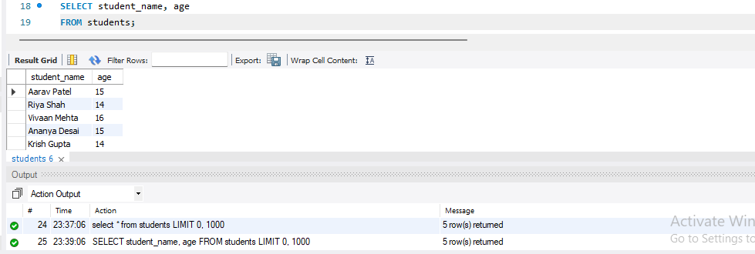

• Lab 2: Write SQL queries to retrieve all students whose age is greater than 10.
To retrieve all students whose age is greater than 10, use this SQL query:
SELECT *
FROM students
WHERE age > 10;
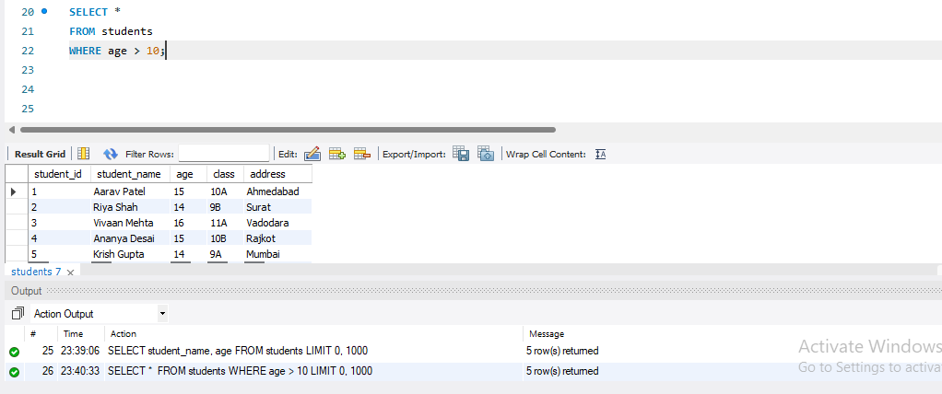

3. SQL Constraints
Theory Questions:
1. What are constraints in SQL? List and explain the different types of constraints.
Constraints in SQL are rules applied to table columns to restrict and control the type of data that can be stored. They help maintain data accuracy and integrity in a database.

Types of Constraints in SQL\
- NOT NULL
  - Ensures a column cannot have a NULL (empty) value
  - Example: Every student must have a name
- UNIQUE
  - Ensures all values in a column are different
  - Example: No two students can have the same email
- PRIMARY KEY
  - Uniquely identifies each record in a table
  - Combination of NOT NULL + UNIQUE
  - Example: student_id
- FOREIGN KEY
  - Links one table with another
  - Ensures referential integrity
  - Example: class_id referencing another table
- CHECK
  - Ensures values meet a specific condition
  - Example: age must be greater than 5
- DEFAULT
  - Assigns a default value if no value is provided
  - Example: default city = 'Surat'

2. How do PRIMARY KEY and FOREIGN KEY constraints differ?

Difference between PRIMARY KEY and FOREIGN KEY (Short Answer)
Feature | PRIMARY KEY | FOREIGN KEY
Purpose | Uniquely identifies each record in a table | Links one table to another
Uniqueness | Must be unique | Can have duplicate values
NULL Values | Cannot be NULL | Can be NULL
Number per Table | Only one primary key (can be composite) | Multiple foreign keys allowed
Role | Ensures entity integrity | Ensures referential integrity

- What is the role of NOT NULL and UNIQUE constraints?
The role of NOT NULL and UNIQUE constraints
- NOT NULL
  - Ensures that a column cannot have empty (NULL) values
  - Every record must contain a value in that column
- UNIQUE
  - Ensures that all values in a column are different (no duplicates allowed)

LAB EXERCISES:
• Lab 1: Create a table teachers with the following columns: teacher_id (Primary Key), teacher_name (NOT NULL), subject (NOT NULL), and email (UNIQUE).
CREATE TABLE teachers (
teacher_id INT PRIMARY KEY,
teacher_name VARCHAR(100) NOT NULL,
subject VARCHAR(100) NOT NULL,
email VARCHAR(100) UNIQUE
);
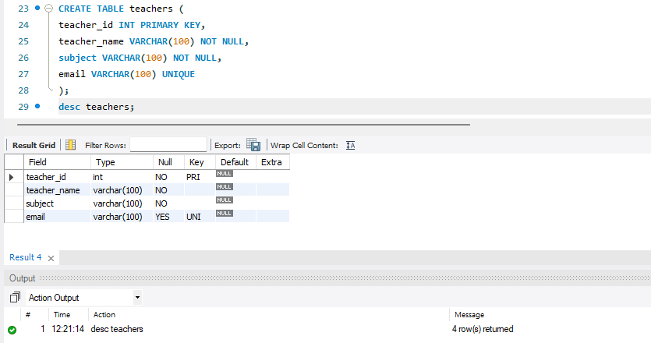

• Lab 2: Implement a FOREIGN KEY constraint to relate the teacher_id from the teachers table with the students table.
-- Step 1: Add column
ALTER TABLE students
ADD teacher_id INT;

-- Step 2: Add FOREIGN KEY
ALTER TABLE students
ADD CONSTRAINT fk_teacher
FOREIGN KEY (teacher_id)
REFERENCES teachers(teacher_id);
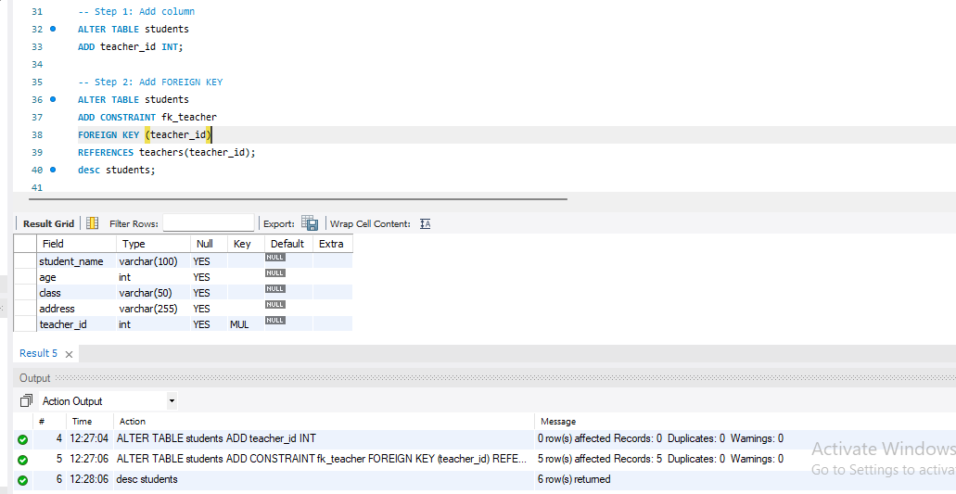

4. Main SQL Commands and Sub-commands (DDL) Theory Questions:

1. Define the SQL Data Definition Language (DDL).
Data Definition Language (DDL) is a set of SQL commands used to define, create, modify, and delete database structures such as tables, databases, and schemas.

Examples of DDL Commands:
- CREATE → Creates database objects (tables, databases)
- ALTER → Modifies existing structures
- DROP → Deletes objects
- TRUNCATE → Removes all records from a table

Syntax (for creating a table):
CREATE TABLE table_name (
column1 datatype constraints,
column2 datatype constraints,
...
);

2. Explain the CREATE command and its syntax.
The CREATE command in SQL is a Data Definition Language (DDL) command used to create new database objects such as databases, tables, views, indexes, etc.
Purpose of CREATE
It is used to define and set up the structure of data in a database.

🧾 Syntax of CREATE TABLE
CREATE TABLE table_name (
column1 datatype constraints,
column2 datatype constraints,
column3 datatype constraints,
...
);

🔑 Explanation
- CREATE TABLE → Command to create a new table
- table_name → Name of the table
- column1, column2... → Names of columns
- datatype → Type of data (e.g., INT, VARCHAR, DATE)
- constraints → Rules (e.g., PRIMARY KEY, NOT NULL, UNIQUE)

✅ Example
CREATE TABLE students (
student_id INT PRIMARY KEY,
student_name VARCHAR(50) NOT NULL,
age INT,
class VARCHAR(10)
);

✔️ What this does:
- Creates a table named students
- Adds columns:
  - student_id → Integer and Primary Key
  - student_name → Text, cannot be empty
  - age → Integer
  - class → Text

🗂️ Other CREATE Commands
- Create Database
CREATE DATABASE school_db;
- Create View
CREATE VIEW student_view AS
SELECT student_name, class FROM students;

If you want, I can also give you short exam notes or practice questions 👍
Explain the CREATE command and its syntax.
The CREATE command in SQL is a DDL (Data Definition Language) command used to create new database objects such as tables, databases, views, and indexes.

📌 Purpose
It is used to define the structure of data in a database.

🧾 Syntax of CREATE TABLE
CREATE TABLE table_name (
column1 datatype constraints,
column2 datatype constraints,
...
);

🔑 Explanation
- CREATE TABLE → Creates a new table
- table_name → Name of the table
- column name → Field in the table
- datatype → Type of data (INT, VARCHAR, etc.)
- constraints → Rules like PRIMARY KEY, NOT NULL, UNIQUE

✅ Example
CREATE TABLE students (
student_id INT PRIMARY KEY,
student_name VARCHAR(50) NOT NULL,
age INT,
class VARCHAR(10)
);
👉 This creates a table students with four columns and applies constraints.

🗂️ Other CREATE Commands

1. Create Database
CREATE DATABASE school_db;

2. Create View
CREATE VIEW student_view AS
SELECT student_name, class FROM students;

3.What is the purpose of specifying data types and constraints during table creation?
LAB EXERCISES:
• Lab 1: Create a table courses with columns: course_id, course_name, and course_credits. Set the course_id as the primary key.
CREATE TABLE courses (
course_id INT PRIMARY KEY,
course_name VARCHAR(50),
course_credits INT
);
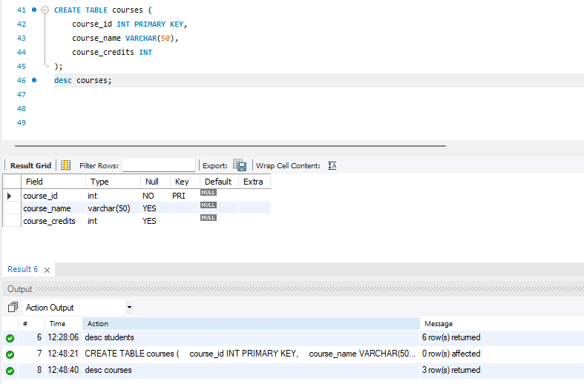

• Lab 2: Use the CREATE command to create a database university_db.
CREATE DATABASE university_db;

5.ALTER Command
- Theory Questions:

1. What is the use of the ALTER command in SQL?
The ALTER command is a DDL (Data Definition Language) statement used to modify the structure of an existing database object, mainly a table.
Use of ALTER
It is used when you want to:
- Add a new column
- Delete a column
- Change a column’s data type
Rename a column or table
1. Add a column
ALTER TABLE table_name
ADD column_name datatype;

2. How can you add, modify, and drop columns from a table using ALTER?
ANS:- The ALTER command in SQL is used to modify an existing table structure, such as adding, changing, or deleting columns.
1. Add a Column

🧾 Syntax
ALTER TABLE table_name
ADD column_name datatype;

✅ Example
ALTER TABLE students
ADD email VARCHAR(50);
👉 Adds a new column email to the students table.
2. Modify a Column

🧾 Syntax
ALTER TABLE table_name
MODIFY column_name new_datatype;
(In some databases like MySQL, use MODIFY; in others like SQL Server, use ALTER COLUMN)

✅ Example
ALTER TABLE students
MODIFY age INT;
👉 Changes the datatype of age column.
3. Drop a Column

🧾 Syntax
ALTER TABLE table_name
DROP COLUMN column_name;

✅ Example
ALTER TABLE students
DROP COLUMN email;
👉 Removes the email column completely from the table.
LAB EXERCISES:
• Lab 1: Modify the courses table by adding a column course_duration using the ALTER command.
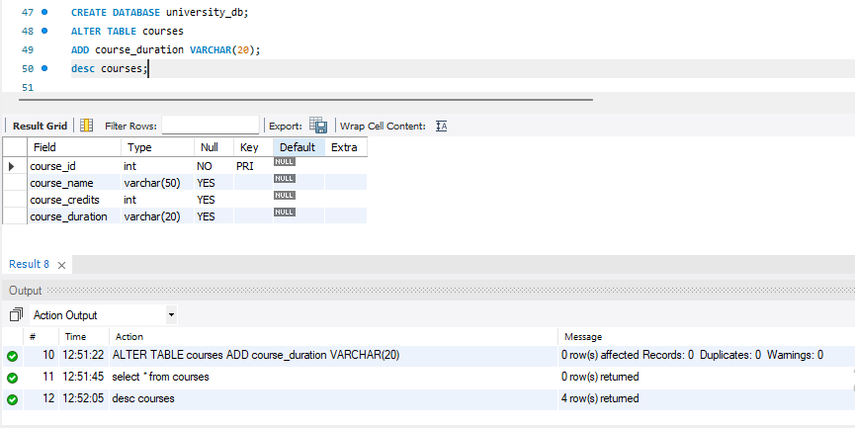

• Lab 2: Drop the course_credits column from the courses table.
ALTER TABLE courses
DROP COLUMN course_credits;
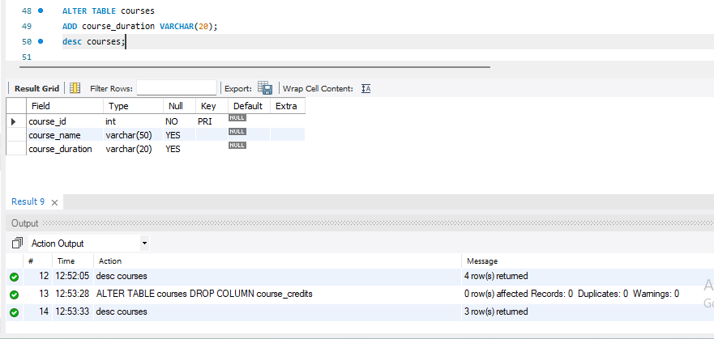
6. DROP Command Theory Questions:
1. What is the function of the DROP command in SQL?
ANS:- The DROP command in SQL is a DDL (Data Definition Language) command used to permanently delete database objects such as tables, databases, views, or indexes.
Function of DROP
- Removes the entire object from the database
- Deletes both structure and data
- The action is permanent (cannot be undone easily)
Syntax

1. Drop a Table
DROP TABLE table_name;

2. Drop a Database
DROP DATABASE database_name;
Example
DROP TABLE students;
This will:
- Delete the students table
- Remove all its records and structure completely
2. What are the implications of dropping a table from a database?
ANS:- Dropping a table using the DROP TABLE command has several important implications:
1. Permanent Data Loss
- All data (records) in the table is deleted permanently
- The structure (columns, constraints) is also removed
- You cannot recover it unless a backup exists
2. Table Structure is Removed
- The table definition (schema) is completely deleted
- You must recreate the table from scratch if needed
3. Affects Relationships (Foreign Keys)
- If other tables are linked using foreign keys, dropping the table can:
  - Cause errors, or
  - Require you to drop dependent tables first
4. Loss of Indexes and Constraints
- All associated indexes, primary keys, foreign keys, and constraints are deleted
5. Frees Storage Space
- The space used by the table in the database is released
6. No WHERE Clause (Full Removal)
- Unlike DELETE, DROP removes the entire table, not selected rows
7. Cannot Be Rolled Back (in most cases)
- In many database systems, DROP is auto-committed
- You cannot undo it using ROLLBACK
Example
DROP TABLE students;

LAB EXERCISES:
• Lab 1: Drop the teachers table from the school_db database.
DROP TABLE teachers;
• Lab 2: Drop the students table from the school_db database and verify that the table has been removed.
DROP TABLE students;
7. Data Manipulation Language (DML)
Theory Questions:
1. Define the INSERT, UPDATE, and DELETE commands in SQL.
ANS:-
1. INSERT Command
The INSERT command is used to add new records (rows) into a table.
Syntax:
INSERT INTO table_name (column1, column2, column3)
VALUES (value1, value2, value3);
Example:
INSERT INTO students (student_id, student_name, age)
VALUES (1, 'Rahul', 20);
2. UPDATE Command
The UPDATE command is used to modify existing records in a table.
👉 Syntax:
UPDATE table_name
SET column1 = value1, column2 = value2
WHERE condition;
Example:
UPDATE students
SET age = 21
WHERE student_id = 1;
If you don’t use a WHERE clause, all records will be updated.
3. DELETE Command
The DELETE command is used to remove records from a table.
👉 Syntax:
DELETE FROM table_name
WHERE condition;
👉 Example:
DELETE FROM students
WHERE student_id = 1;
2. What is the importance of the WHERE clause in UPDATE and DELETE operations?
1. INSERT Command
The INSERT command is used to add new records (rows) into a table.
Syntax:
INSERT INTO table_name (column1, column2, column3)
VALUES (value1, value2, value3);
Example:
INSERT INTO students (student_id, student_name, age)
VALUES (1, 'Rahul', 20);
2. UPDATE Command
The UPDATE command is used to modify existing records in a table.
Syntax:
UPDATE table_name
SET column1 = value1, column2 = value2
WHERE condition;
Example:
UPDATE students
SET age = 21
WHERE student_id = 1;
If you don’t use a WHERE clause, all records will be updated.
3. DELETE Command
The DELETE command is used to remove records from a table.
Syntax:
DELETE FROM table_name
WHERE condition;
Example:
DELETE FROM students
WHERE student_id = 1;
If you don’t use a WHERE clause, all records in the table will be deleted.
Summary:
- INSERT → Add new data
- UPDATE → Modify existing data
- DELETE → Remove data
If you want, I can also give you short exam answers (2 marks / 5 marks) 👍
What is the importance of the WHERE clause in UPDATE and DELETE operations?
The WHERE clause is extremely important in UPDATE and DELETE operations because it controls which records are affected.
Importance of WHERE Clause
- Targets Specific Rows
It allows you to update or delete only the records that meet a certain condition.
👉 Without it, SQL cannot filter data.
- Prevents Data Loss
  - In UPDATE: all rows will be modified
  - In DELETE: all rows will be removed
This can cause serious data loss if used carelessly.
- Improves Accuracy
Ensures that only the correct records are changed or deleted.
Example
With WHERE (safe):
UPDATE students
SET age = 22
WHERE student_id = 2;
Only one specific record is updated
Without WHERE (dangerous):
UPDATE students
SET age = 22;
All records in the table will be updated

DELETE Example:
DELETE FROM students
WHERE student_id = 2;
Deletes only one record
DELETE FROM students;
Deletes all records

LAB EXERCISES:
• Lab 1: Insert three records into the courses table using the INSERT command.
INSERT INTO courses (course_id, course_name, course_duration)
VALUES
(101, 'Mathematics', '3 months'),
(102, 'Computer Science', '4 months'),
(103, 'Physics', '3 months');

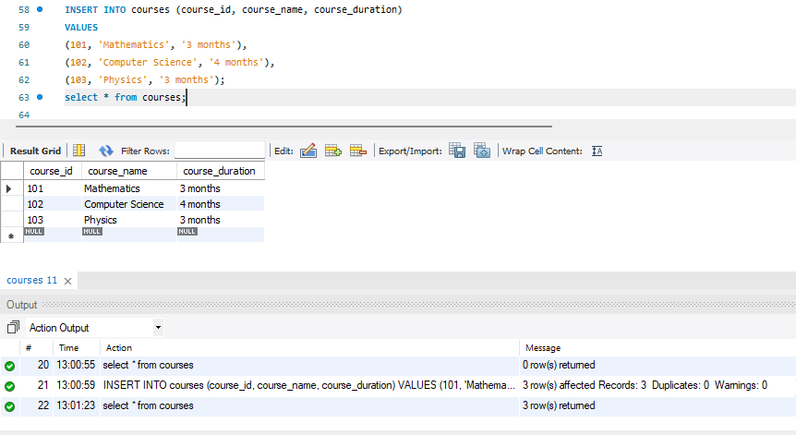
• Lab 2: Update the course duration of a specific course using the UPDATE command.

UPDATE courses
SET course_duration = '6 months'
WHERE course_id = 101; 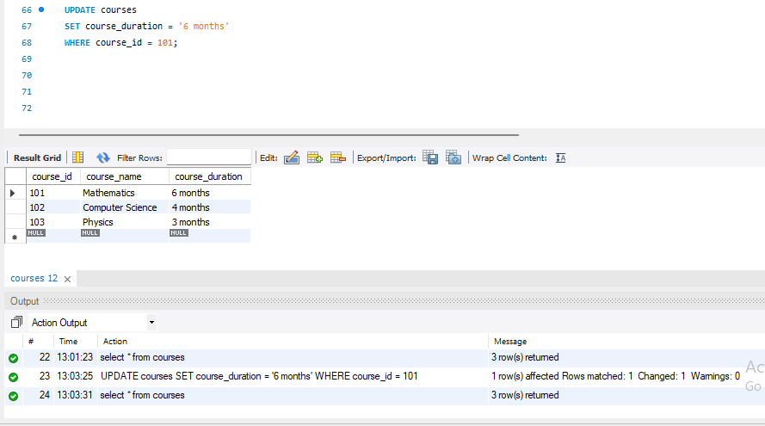
• Lab 3: Delete a course with a specific course_id from the courses table using the DELETE command.
DELETE FROM courses
WHERE course_id = 101; 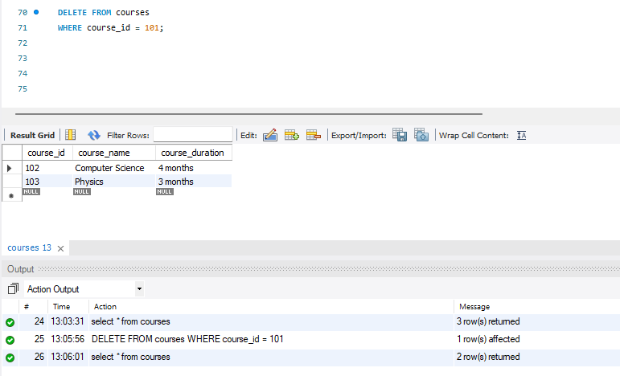
- Data Query Language (DQL)
Theory Questions:
1. What is the SELECT statement, and how is it used to query data?
The SELECT statement in SQL is used to retrieve (fetch) data from a database table. It allows you to view specific columns or all data stored in the table.
Basic Syntax
SELECT column1, column2, ...
FROM table_name;
👉 To get all columns:
SELECT * FROM table_name;
How it is Used to Query Data
- Retrieve specific columns
SELECT student_name, age
FROM students;
- Retrieve all data
SELECT * FROM students;
- Filter data using WHERE
SELECT *
FROM students
WHERE age > 18;
- Sort data using ORDER BY
SELECT *
FROM students
ORDER BY age DESC;

2. Explain the use of the ORDER BY and WHERE clauses in SQL queries.
- LAB EXERCISES:
• Lab 1: Retrieve all courses from the courses table using the SELECT statement.
SELECT * FROM courses;
• Lab 2: Sort the courses based on course_duration in descending order using ORDER BY.
SELECT * FROM coursesORDER BY course_duration DESC; 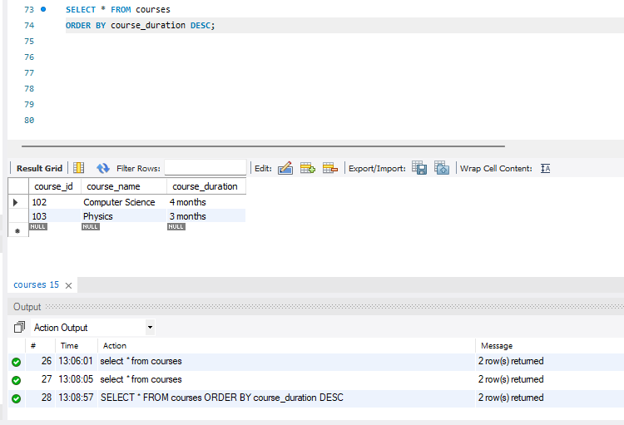
• Lab 3: Limit the results of the SELECT query to show only the top two courses using LIMIT.
SELECT * FROM courses
LIMIT 2; 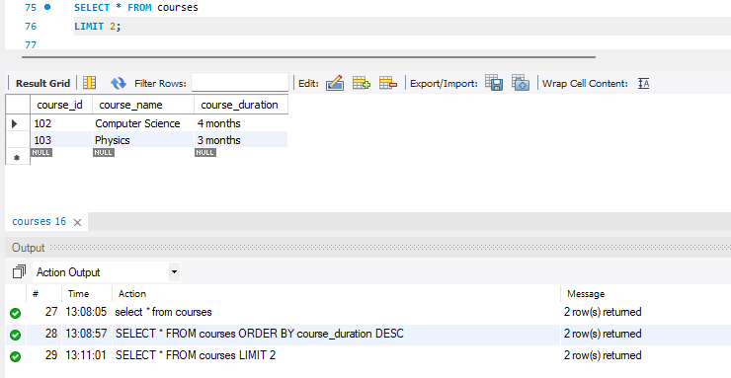
9. Data Control Language (DCL)

Theory Questions:

1. What is the purpose of GRANT and REVOKE in SQL?

1. GRANT Command
The GRANT command is used to give permissions (privileges) to users.
Purpose:
Allows a user to perform specific actions like SELECT, INSERT, UPDATE, DELETE on a table.
Syntax:
GRANT privilege_name
ON table_name
TO user_name;
Example:
GRANT SELECT, INSERT
ON students
TO user1;
✔ Now user1 can view and add data to the table.

🔹 2. REVOKE Command
The REVOKE command is used to remove permissions from users.
Purpose:
Stops a user from performing certain actions on a table.
Syntax:
REVOKE privilege_name
ON table_name
FROM user_name;
Example:
REVOKE INSERT
ON students
FROM user1;
How do you manage privileges using these commands?
To manage privileges in SQL, you use GRANT and REVOKE commands to control user access to database objects (like tables).
Steps to Manage Privileges
1. Grant Privileges (Give Access)
Use GRANT to allow users to perform actions.
Example:
GRANT SELECT, INSERT
ON students
TO user1;
✔ user1 can now view and add data
2. Grant All Privileges
GRANT ALL PRIVILEGES
ON students
TO user1;
Gives full access (SELECT, INSERT, UPDATE, DELETE)
3. Revoke Privileges (Remove Access)
Use REVOKE to take back permissions.
Example:
REVOKE INSERT
ON students
FROM user1;
user1 can no longer insert data
4. Revoke All Privileges
REVOKE ALL PRIVILEGES
ON students
FROM user1;
Removes all access rights
LAB EXERCISES:
• Lab 1: Create two new users user1 and user2 and grant user1 permission to SELECT from the courses table. •
Lab 2: Revoke the INSERT permission from user1 and give it to user2.
10. Transaction Control Language (TCL)
Theory Questions:

  - What is the purpose of the COMMIT and ROLLBACK commands in SQL?
The COMMIT and ROLLBACK commands in SQL are Transaction Control Language (TCL) commands used to manage transactions (a group of SQL operations executed together).
COMMIT
Purpose
- Saves all changes made during the transaction permanently in the database
- Once committed, changes cannot be undone
Syntax
COMMIT;
Example
After inserting or updating data:
INSERT INTO students VALUES (1, 'John', 20);
COMMIT;
The changes are now permanently stored.
ROLLBACK
Purpose
- Undoes changes made during the transaction
- Restores the database to the last committed state
Syntax
ROLLBACK;
Example
DELETE FROM students WHERE student_id = 1;
ROLLBACK;

2. Explain how transactions are managed in SQL databases.
LAB EXERCISES: • Lab 1: Insert a few rows into the courses table and use COMMIT to save the changes.
• Lab 2: Insert additional rows, then use ROLLBACK to undo the last insert operation.
• Lab 3: Create a SAVEPOINT before updating the courses table, and use it to roll back specific changes.
11. SQL Joins Theory Questions: 1. Explain the concept of JOIN in SQL. What is the difference between INNER JOIN, LEFT JOIN, RIGHT JOIN, and FULL OUTER JOIN?
2. How are joins used to combine data from multiple tables?
LAB EXERCISES: • Lab 1: Create two tables: departments and employees. Perform an INNER JOIN to display employees along with their respective departments.
• Lab 2: Use a LEFT JOIN to show all departments, even those without employees.
12. SQL Group By Theory Questions: 1. What is the GROUP BY clause in SQL? How is it used with aggregate functions? 2. Explain the difference between GROUP BY and ORDER BY.
LAB EXERCISES:
• Lab 1: Group employees by department and count the number of employees in each department using GROUP BY.
• Lab 2: Use the AVG aggregate function to find the average salary of employees in each department.
13. SQL Stored Procedure Theory Questions: 1. What is a stored procedure in SQL, and how does it differ from a standard SQL query? 2. Explain the advantages of using stored procedures.
LAB EXERCISES:
• Lab 1: Write a stored procedure to retrieve all employees from the employees table based on department.
• Lab 2: Write a stored procedure that accepts course_id as input and returns the course details.
14. SQL View Theory Questions: 1. What is a view in SQL, and how is it different from a table? 2. Explain the advantages of using viewsin SQL databases.
LAB EXERCISES:
• Lab 1: Create a view to show all employees along with their department names.
• Lab 2: Modify the view to exclude employees whose salaries are below $50,000.
15. SQL Triggers Theory Questions: 1. What is a trigger in SQL? Describe its types and when they are used. 2. Explain the difference between INSERT, UPDATE, and DELETE triggers.
LAB EXERCISES:
• Lab 1: Create a trigger to automatically log changes to the employees table when a new employee is added.
• Lab 2: Create a trigger to update the last_modified timestamp whenever an employee record is updated.
16. Introduction to PL/SQL Theory Questions: 1. What is PL/SQL, and how does it extend SQL's capabilities? 2. List and explain the benefits of using PL/SQL.
LAB EXERCISES:
• Lab 1: Write a PL/SQL block to print the total number of employees from the employees table.
• Lab 2: Create a PL/SQL block that calculates the total sales from an orders table.
17. PL/SQL Control Structures Theory Questions: 1. What are control structures in PL/SQL? Explain the IF-THEN and LOOP control structures. 2. How do control structures in PL/SQL help in writing complex queries?
LAB EXERCISES:
• Lab 1: Write a PL/SQL block using an IF-THEN condition to check the department of an employee.
• Lab 2: Use a FOR LOOP to iterate through employee records and display their names.
18. SQL Cursors Theory Questions: 1. What is a cursor in PL/SQL? Explain the difference between implicit and explicit cursors. 2. When would you use an explicit cursor over an implicit one?

LAB EXERCISES:

• Lab 1: Write a PL/SQL block using an explicit cursor to retrieve and display employee details.

• Lab 2: Create a cursor to retrieve all courses and display them one by one.
19. Rollback and Commit Savepoint Theory Questions: 1. Explain the concept of SAVEPOINT in transaction management. How do ROLLBACK and COMMIT interact with savepoints? 2. When is it useful to use savepoints in a database transaction?

LAB EXERCISES:
• Lab 1: Perform a transaction where you create a savepoint, insert records, then rollback to the savepoint.

• Lab 2: Commit part of a transaction after using a savepoint and then rollback the remaining changes.

EXTRA LAB PRACTISE FOR DATABASE CONCEPTS 1. Introduction to SQL

LAB EXERCISES:
• Lab 3: Create a database called library_db and a table books with columns: book_id, title, author, publisher, year_of_publication, and price. Insert five records into the table.

• Lab 4: Create a table members in library_db with columns: member_id, member_name, date_of_membership, and email. Insert five records into this table.

2. SQL Syntax LAB EXERCISES:
• Lab 3: Retrieve all members who joined the library before 2022. Use appropriate SQL syntax with WHERE and ORDER BY.
• Lab 4: Write SQL queries to display the titles of books published by a specific author. Sort the results by year_of_publication in descending order.
3. SQL Constraints LAB EXERCISES:
• Lab 3: Add a CHECK constraint to ensure that the price of books in the books table is greater than 0.
• Lab 4: Modify the members table to add a UNIQUE constraint on the email column, ensuring that each member has a unique email address.
4. Main SQL Commands and Sub-commands (DDL) LAB EXERCISES: •
Lab 3: Create a table authors with the following columns: author_id, first_name, last_name, and country. Set author_id as the primary key.
• Lab 4: Create a table publishers with columns: publisher_id, publisher_name, contact_number, and address. Set publisher_id as the primary key and contact_number as unique.
5. ALTER Command LAB EXERCISES: •
Lab 3: Add a new column genre to the books table. Update the genre for all existing records.
• Lab 4: Modify the members table to increase the length of the email column to 100 characters.
6. DROP Command LAB EXERCISES:
• Lab 3: Drop the publishers table from the database after verifying its structure.
• Lab 4: Create a backup of the members table and then drop the original members table.
7. Data Manipulation Language (DML) LAB EXERCISES:
• Lab 4: Insert three new authors into the authors table, then update the last name of one of the authors.
• Lab 5: Delete a book from the books table where the price is higher than $100.
8. UPDATE Command LAB EXERCISES:
• Lab 3: Update the year_of_publication of a book with a specific book_id.
• Lab 4: Increase the price of all books published before 2015 by 10%. 9. DELETE Command LAB EXERCISES:
• Lab 3: Remove all members who joined before 2020 from the members table.
• Lab 4: Delete all books that have a NULL value in the author column.
10. Data Query Language (DQL) LAB EXERCISES:
• Lab 4: Write a query to retrieve all books with price between $50 and $100.
• Lab 5: Retrieve the list of books sorted by author in ascending order and limit the results to the top 3 entries.
11. Data Control Language (DCL) LAB EXERCISES:
• Lab 3: Grant SELECT permission to a user named librarian on the books table.
• Lab 4: Grant INSERT and UPDATE permissions to the user admin on the members table.
12. REVOKE Command LAB EXERCISES:
• Lab 3: Revoke the INSERT privilege from the user librarian on the books table.
• Lab 4: Revoke all permissions from user admin on the members table.
13. Transaction Control Language (TCL) LAB EXERCISES:
• Lab 3: Use COMMIT after inserting multiple records into the books table, then make another insertion and perform a ROLLBACK.
• Lab 4: Set a SAVEPOINT before making updates to the members table, perform some updates, and then roll back to the SAVEPOINT.
14. SQL Joins LAB EXERCISES:
• Lab 3: Perform an INNER JOIN between books and authors tables to display the title of books and their respective authors' names.
• Lab 4: Use a FULL OUTER JOIN to retrieve all records from the books and authors tables, including those with no matching entries in the other table.
15. SQL Group By LAB EXERCISES:
• Lab 3: Group books by genre and display the total number of books in each genre.
• Lab 4: Group members by the year they joined and find the number of members who joined each year.
16. SQL Stored Procedure LAB EXERCISES:
• Lab 3: Write a stored procedure to retrieve all books by a particular author.
• Lab 4: Write a stored procedure that takes book_id as an argument and returns the price of the book.
17. SQL View LAB EXERCISES:
• Lab 3: Create a view to show only the title, author, and price of books from the books table.
• Lab 4: Create a view to display members who joined before 2020.
18. SQL Trigger LAB EXERCISES:
• Lab 3: Create a trigger to automatically update the last_modified timestamp of the books table whenever a record is updated.
• Lab 4: Create a trigger that inserts a log entry into a log_changes table whenever a DELETE operation is performed on the books table.
19. Introduction to PL/SQL LAB EXERCISES:
• Lab 3: Write a PL/SQL block to insert a new book into the books table and display a confirmation message.
• Lab 4: Write a PL/SQL block to display the total number of books in the books table.
20. PL/SQL Syntax LAB EXERCISES:
• Lab 3: Write a PL/SQL block to declare variables for book_id and price, assign values, and display the results.
• Lab 4: Write a PL/SQL block using constants and perform arithmetic operations on book prices.
21. PL/SQL Control Structures LAB EXERCISES:
• Lab 3: Write a PL/SQL block using IF-THEN-ELSE to check if a book's price is above $100 and print a message accordingly.
• Lab 4: Use a FOR LOOP in PL/SQL to display the details of all books one by one.
22. SQL Cursors LAB EXERCISES:
• Lab 3: Write a PL/SQL block using an explicit cursor to fetch and display all records from the members table.
• Lab 4: Create a cursor to retrieve books by a particular author and display their titles.
23. Rollback and Commit Savepoint LAB EXERCISES:
• Lab 3: Perform a transaction that includes inserting a new member, setting a SAVEPOINT, and rolling back to the savepoint after making updates.
• Lab 4: Use COMMIT after successfully inserting multiple books into the books table, then use ROLLBACK to undo a set of changes made after a savepoint. Module 6) Python Fundamentals Introduction to Python Theory: • Introduction to Python and its Features (simple, high-level, interpreted language). • History and evolution of Python. • Advantages of using Python over other programming languages. • Installing Python and setting up the development environment (Anaconda, PyCharm, or VS Code). • Writing and executing your first Python program. Lab: • Write a Python program that prints "Hello, World!". • Set up Python on your local machine and write a program to display your name. 2. Programming Style Theory: • Understanding Python’s

